Comparison Between different storages used in computers

Types of different storages

Register: Smallest unit of storage. It is a part of CPU itself. It works very close to cpu.

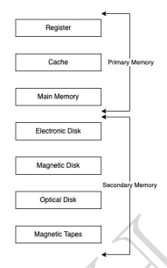

Cache – It helps cpu in fetching processes which are worked upon by os very often.

* Primary memory contains – Register, cache, main memory(RAM)
  + Cost of accessing memory is lower in cache rather than main memory
  + Main memory - processes resides here
* Secondary Memory (Hard Disk) - Files such as videos and images, also programs resides here in secondary memory
  + Audio, video projects
  + One more e.g. is SSD resides here as it resides here

Comparison based on

1. Cost
   1. Cost of primary memory is more as it has best material need for fast access
   2. Caches is cheaper than register and costly than registers
   3. Harddisks are more cheaper
2. Access Speed: Register> cache> mainmemory> Scrondary memories
3. Storage size: Register<cache(kb’s)<mainmemory(gb’s)< harddisks(TBs)
4. Volatility: Amount of processes are lost are lost after computer being turned of
   1. Primary memories are flushed off, but Scondary memories stay non volatile.